KDEON Revenue Forecast
Sepsis occurs in 1% to 2% of all hospitalizations in the United States; at least 750,000 people annually - more than AMI, lung cancer, and other commonly known causes of death in the hospital.
More than 215,000 people will die from the condition. With standard supportive care alone, mortality remains unacceptably high, at 28-50%. (Natanson, 1998)
(1856 JAMA, October 27, 2010—Vol 304, No. 16)
According to an August 2013 study conducted by the Agency for Healthcare Research and Quality, a division of the United States Department of Health and Human Services (HHS):
  - Sepsis is the most expensive condition treated in hospitals
  - Annual costs to the U.S healthcare system exceed $20 billion
  - Sepsis accounted for 5.2% of the national costs for hospitalization in 2011
  - Sepsis was also the most expensive condition billed to Medicare (6.9%) This figure does not account for the costs related to treatment following hospital discharge, as sepsis patients who survive often experience lifelong complications. Therefore, total sepsis-related healthcare costs in the United States are likely substantially higher.
A September 2013 brief by the same agencies found hospitalization rates for sepsis in adults aged 45-65 rose 180% in 2011.
Another September 2013 brief found a 32% increase in sepsis hospitalizations from 2005 – 2010.
(http://www.hcup-us.ahrq.gov/reports/statbriefs/sb160.jsp)
LEK Consulting Formula for Forecasting New Product Revenues: Customer Base X Total Penetration X Product’s Share of Penetration X Price Per Unit X Units Per Year
Customer Base (Incidence, number of new potential customers each year; appropriate as product serves a one-time acute event) = 750,000 sepsis cases (2010) – 990,000 (2015) (estimated, based on historic 32% increase in 20005-2010 sepsis hospitalizations ) / 215,000 deaths (2010) – 285,000 deaths (2015, estimated)
Total Penetration (particularly important, as there are currently NO FDA approved treatments for sepsis; Xigris, the last commercially available treatment, was withdrawn in 2011)
Qualitative Drivers in Sepsis Patient Base (taken from LEK Osteoporosis study
Factor |  |  |  |  | Impact
Increasing age of Population
Increased physician awareness of sepsis
Improved access to diagnostic equipment
Higher incentive to diagnose due to increased effectiveness of treatment options
Increased support from health care payers
United States Annual Patient Population by Sepsis Stage
Sepsis Stage | Symptoms | 2010 | 2015 | Target
4 – Septic Shock | Sepsis w/ persisting arterial hypotension or hypoperfusion | 215,000* | 285,000*^{ǂ}
3 – Severe Sepsis | Sepsis plus organ dysfunction, hypotension or hypoperfusion | ^  ^  ^  ^ | ^  ^  ^  ^
2 – Sepsis | SIRS w/ confirmed infectious process
1 – SIRS | Systemic Inflammatory Response Syndrome | 750,000 | 990,000^{ǂ}

2010 figures are taken from (1856 JAMA, October 27, 2010—Vol 304, No. 16). It should be noted the 215,000 figure is cited from Natanson, in 1998. 2015 estimates based on previously observed increase in sepsis hospitalizations from 2005-2010 (http://www.hcup-us.ahrq.gov/reports/statbriefs/sb160.jsp). The combination of 1998 mortality data and static 32% historical increase in a growing, aging population tends to a conservative projection. (* deaths from sepsis, ^{ǂ} estimated)
Therapeutic Objective - Decrease morbidity and treat patients who present with clinical indication of gram negative bacterial infection. Early intervention with KDEON is intended to prevent inflammation and subsequent advancement of sepsis stages.
Average annual cost per sepsis patient hospitalization to US healthcare system - $26,666 ($20B/0.75M)
Average increase length of stay for those hospitalized for septicemia or sepsis compared with those hospitalized for other conditions ranged from 2.6 to 4.8 days:
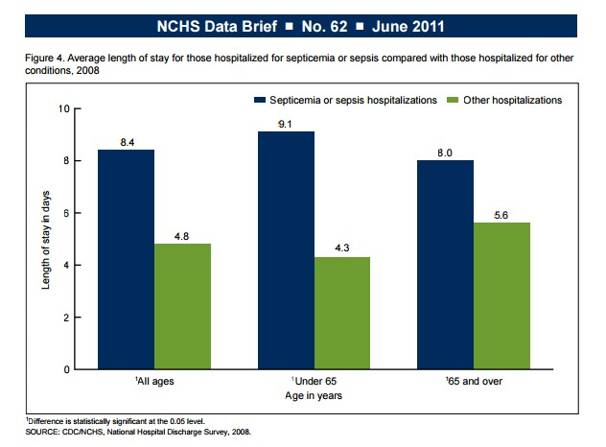
At a cost of roughly $3175 per day, this translates to $7,620 to $15,240 in increased cost per patient, with an overall average increased cost of $11,435 across all ages.
Clearly, one should be able to anticipate successful therapeutic intervention with KDEON would result in a decrease in the length of stay, to say nothing of the treatment costs incurred in sepsis stage progression from SIRS to septic shock.
Product’s Share of Penetration – This factor is likely to be dependent on a number of factors; for simplicity, we can look at a range of product share. Product efficacy, awareness, marketing, economic impact, etc. will all play a role in determining the KDEON product share. The vast majority of indicators would argue toward a substantial % of product share, given the lack of currently available options on the market.
Price Per Unit – The price per unit of KDEON is difficult to determine at this time, given it is dependent on dosage, direct manufacturing costs, profit margin and a host of other factors. Conservatively, we can expect that a price point per total patient episode which results in at least one day shorter hospital stay is economically attractive to the payer. Additional gains would be a strong driver of product share. As such, we can look at a range of < $3175 per patient as being economically advantageous to the payer. Again, we can look at a range of price points.
Units Per Year – Units Per Year would be dependent on Customer Base x Number of Units per Customer (patient) Again, we could look at a range, with a minimum of 1 unit per patient.
(Insert Excel data, graphs, etc. to show various projections based on conservative baseline figures and expanding along a range…)
Customer Base X Total Penetration X Product’s Share of Penetration X Price Per Unit X Units Per Year
For simplicity’s sake, we can assume the Customer Base is 1 Million, the Total Penetration is 100% (all diagnosed sepsis patients receive “some form of treatment”) and thus the “Product’s Share of Penetration” will be some fraction of the nominal 1 Million Patients. Price per Unit will be computed over a range, and Units per Year will be transposed to Units per Patient hospitalization, as sepsis, in KDEON terms, is viewed as an acute, episodic illness with immediate care regimen required. The Number of Units per Patient Hospitalization will also be computed across a range.
This allows for a simplified 3 Factor Formula for Revenue Projections:
(Customer Base X Total Penetration X Product’s Share of Penetration) which we will shorten to PSP
PSP X Price Per Unit (PPU) X Units Per Patient Hospitalization (UPPH) = REV (Annual Revenue in $M, USA)
PSP  (M Patients) | PPU  ($) | UPPH | REV ($M) | PSP  (M Patients) | PPU | UPPH | REV ($M)
0.1 | 500 | 1 | 50 | 0.1 | 1000 | 1 | 100
0.1 | 500 | 3 | 150 | 0.1 | 1000 | 3 | 300
0.1 | 500 | 5 | 250 | 0.1 | 1000 | 5 | 500
0.1 | 500 | 10 | 500 | 0.1 | 1000 | 10 | 1000
0.25 | 500 | 1 | 125 | 0.25 | 1000 | 1 | 250
0.25 | 500 | 3 | 375 | 0.25 | 1000 | 3 | 750
0.25 | 500 | 5 | 625 | 0.25 | 1000 | 5 | 1250
0.25 | 500 | 10 | 1250 | 0.25 | 1000 | 10 | 2500
0.5 | 500 | 1 | 250 | 0.5 | 1000 | 1 | 500
0.5 | 500 | 3 | 750 | 0.5 | 1000 | 3 | 1500
0.5 | 500 | 5 | 1250 | 0.5 | 1000 | 5 | 2500
0.5 | 500 | 10 | 2500 | 0.5 | 1000 | 10 | 5000
0.75 | 500 | 1 | 375 | 0.75 | 1000 | 1 | 750
0.75 | 500 | 3 | 1125 | 0.75 | 1000 | 3 | 2250
0.75 | 500 | 5 | 1875 | 0.75 | 1000 | 5 | 3750
0.75 | 500 | 10 | 3750 | 0.75 | 1000 | 10 | 7500
0.9 | 500 | 1 | 450 | 0.9 | 1000 | 1 | 900
0.9 | 500 | 3 | 1350 | 0.9 | 1000 | 3 | 2700
0.9 | 500 | 5 | 2250 | 0.9 | 1000 | 5 | 4500
0.9 | 500 | 10 | 4500 | 0.9 | 1000 | 10 | 9000

We can see a revenue forecast range from conservative (100,000 patients (10%), utilizing 1 dose per hospital visit, priced at $500 per unit) resulting in $250 Million annual revenue (US only) to “optimistic” (900,000 patients (90%), utilizing 10 doses per hospital visit, priced at $1000 per unit) resulting in $9 Billion annual revenue (US only).
One could predict the growth of revenue will, in large part, occur as a function of time, given that efficacy of treatment has been demonstrated through clinical trials prior to initial sales. Growth will depend on initial early adopters, and public awareness. Medical professionals & major payers would be a primary focus. Manufacturing is straightforward, and scalable. Current a la carte CRO production is nominally $50 per gram, and would decrease on scaling.

